**BUILDING BUS RESERVATION SYSTEM USING PYTHON AND DJANGO FRAMEWORK**

**-VASUGI.A**

**511721104013**

**ABSTRACT**

Online Bus Ticket Reservation System is a Web based application that works within a centralized network. This project presents a review on the software program “Online Bus Ticket Reservation System” as should be used in a bus transportation system, a facility which is used to reserve seats, cancellation of reservation and different types of route enquiries used on securing quick reservations. OBTRS is built for managing and computerizing the traditional database, ticket booking and tracking bus and travel made. It maintains all customer details, bus details, reservation details. To achieve the design, Imo Transport Company (ITC) was chosen as a case study because of its strategic importance to Imo State. Structured Systems Analysis and Design Methodology (SSADM) was adopted. In addition, PHP Hypertext Preprocessor (PHP) language was used for the front- end of the software while the back end was designed using MySQL. The software achieved can improve the customer hand and relationship management in ITC operations. It is recommended that despite the present functionality of the designed software, an additional functionality such as the use of E-mail to send tickets and notifications to the customer and an online payment using credit cards/debit cards should be implemented into the system. Furthermore, other operations carried by ITC such as the courier services should also be integrated to enhance the system.

**BACKGROUND OF STUDY**

The prevalent view in various global circles is that man is presently living in an age growth of information gathering, processing and dissemination, popularly called the information age. For this reason, managers and other users of information especially in transport industries are demanding more kinds of information to support management and operations. They must therefore respond to the increasing requirement for information and data management. Electronic tickets, or e-tickets, gives evidence that their holders have the permission to enter a place of entertainment, use a means of transportation, or have access to some Internet services. The design of this online system will be beneficial to the company because it has not existed before. Therefore, Imo Transport Company, Owerri, a viable investment owned by the state government whose primary objectives are to spread comfort and hospitality to passengers away from their home, to make profit, will appreciate a system which can automate its manual operations in the area of bus ticket reservation in order to meet customers increasing demand during peak and off-peak seasons. The ultimate expectation is to inspire a feasibility study aimed at providing proper guidance and awareness to any future potential investors, particularly those in the bus industry, to consider utilizing the Imo transport, as a gateway to the fertile soil of unlimited opportunities in the south-east Nigeria. Currently, staff at the bus ticket counter is using an internal system to sell tickets at the counter and customers who are unable to buy bus ticket online at this moment would have to go to the counter to a buy bus ticket. Sometimes, customers’ needs to queue up a long queue to buy bus ticket and ask for information and this brings a lot of inconveniences to customers. However, Online Bus Ticket Reservation System enables the customer to buy bus ticket, make payment, and ask for information online easily. Furthermore, staff cancel bus ticket using Bus Ticket Reservation System after checking the bus ticket availability for the customer and print the bus ticket to the customer.

**STATEMENT OF PROBLEM**

Currently, the type of system being used at the counter is an internal system which is manually used in selling the bus tickets. The problems facing the company are that customers must go to the counter to buy bus ticket or ask for bus schedule; customers will also have to queue up for a long time in order to secure a bus ticket and will also need to pay cash when they buy the bus ticket.

**OBJECTIVES OF STUDY**

The main purpose of this study is to automate the manual procedures of reserving a bus ticket for any journey made through Imo Transport Company (ITC). This system is said to be an automatic system and customers can select seats by themselves. Specifically, objectives of this project will consist of:

**i)** Providing a web-based bus ticket reservation function where a customer can buy bus ticket through the online system without a need to queue up at the counter to purchase a bus ticket.

**ii)** Enabling customers to check the availability and types of busses online. Customer can check the time departure for every ITC bus through the system.

**iii)** Easing bus ticket payment by obtaining a bank pin after payments is made to the various designated banks.

**iv)** Ability of customers to cancel their reservation.

**v)** Admin user privileges in updating and cancelling payment, route and vehicle records.

**RESEARCH GAPS**

According to Kevin (2012) Web-based Bus Reservation and Ticketing System is a generic web portal application that aids bus customers to reserve a seat in a certain bus company anytime and anywhere and variety of buses that satisfy the customer’s requirements are provided. The project, on the bus company’s side, serves as a marketing strategy and aids an efficient processing and delivery of itinerary receipts. The project used software like Adobe Photoshop CS4 for the creation of the images, Adobe Dreamweaver CS4 and Notepad++ as a development tool, MySQL for the database, Apache as the web server, m pdf for the creation of PDF and PayPal Sandbox for the payment. For the main effects, it used jQuery. However, the software’s adopted in this project, has in recent times been upgraded. Therefore, Adobe Dreamweaver CS6, Adobe Photoshop CS6, MySQL v.5 is going to be used to implement this project.

**STUDY ON ELECTRONIC TICKETING IN PUBLIC TRANSPORT**

A consultant with European Metropolitan Transport Authority (EMTA), Mohamed Mezhgan (2008) stated that EMTA has established a working group to work on the issue of electronic ticketing. This group is mandated to generate knowledge, exchange/compile information and learn from the experience of its members in the field of electronic ticketing. In his framework, EMTA has launched a study on electronic ticketing in public transport under the supervision of the working group and they designed certain concepts such as the public transport pricing, public transport ticketing and electronic ticketing in public transport. On the contrary, his research which discussed certain concepts in relation to electronic ticketing in public transport was a one-directional article which didn’t relate the idea about customer reserving seats and for their journey at a date chosen by them. Nevertheless, this project will be designed to encapsulate these areas mentioned as well as display certain screenshots of the customers’ reservations system.

**ONLINE TRANSPORT BOOKING SYSTEM**

Baarizah, (2007) emphasized that the Online Transport Booking System which was developed at Polytechnic Kota Kuala Terengganu (PKKT) was to make sure that users could make their online booking or reservations to their desired transport companies with facilities provided by the new system. He pointed out that the methodology and technology being used in this new transport system could be applied to other areas of activities. The user who wants to use the transport must make an application to book the transport before boarding. Similarly, after considering the type of system which Baarizah adopted, this project will be designed with the same aim of presenting the customers of Imo Transport Company with the opportunity of making reservations at the comfort of their homes or offices without being faced with the challenges of queuing at counters before embarking on any journey. This project will also enlighten prospective customers and users of the system on the need to patronize the system as it displays more advantages over the old system by providing an easy-to-use Graphic User interface (GUI) interaction, checking availability of routes before boarding etc.

**RESEARCH METHODOLOGY**

The system of collecting data for research project is known as research methodology. The data may be collected for either theoretical or practical research for example management research may be strategically conceptualized along with operational planning method and change management. Information which was used for this study was carried out by oral interview.

**CHOICE OF METHODOLOGY**

For any project to be completed, it must go through stages called Development Life Cycles. System Development Life Cycle (SDLC) is the process of understanding how an Information System (IS) can support business needs, designing the system, building it and delivering it to users. The SDLC composes of four phases: Planning, Analysis, Design and Implementation. For this project to be developed, the methodology that will be used is the System Structured Analysis and Design Methodology. The SSADM is classified as a Waterfall Development. With Waterfall Development, analyst and users proceed sequentially from one phase to the next and each phase can be mapped out and evaluated (Hevner, 2004). Below, in figure is a diagram on the waterfall methodology.

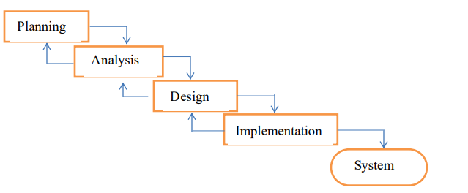

**DATA FLOW DIAGRAM (DFD)**

A data flow diagram (DFD) is a graphical representation of the "flow" of data through an information system, modelling its process aspects. A DFD shows what kind of information will be input to and output from the system, where the data will come from and go to, and where the data will be stored. The development of DFD’S is done in several levels. Each process in lower-level diagrams can be broken down into a more detailed DFD in the next level. The Top-level diagram is often called context diagram. It consists of a single process bit, which plays vital role in studying the current system. The process in the context level diagram is exploded into other process at the first level DFD. Figures shows a data flow diagram about the system.

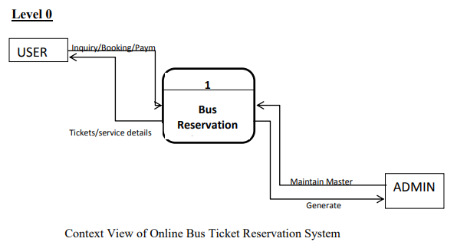

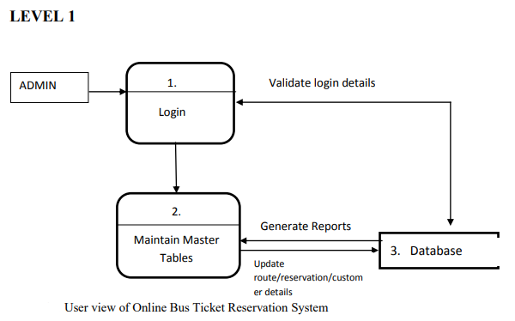

**USE CASE DIAGRAM FOR USERS AND ADMIN**

A use case is a description of a system’s behaviour as it responds to a request that originates from outside of that system (the user). In figure 3.4, a use case of the activities in a bus transport system is shown.

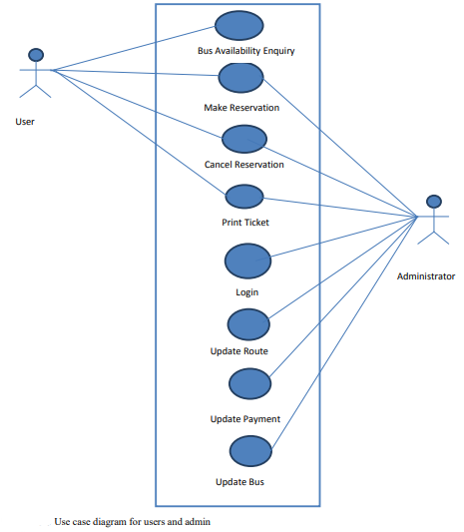

In other words, a use case describes “who” can do “what” with the system in question. The use case technique is used to capture a system’s behavioural requirements by detailing scenario-driven threads through the functional requirements.

**INPUT AND OUTPUT DESIGN**

The input design is the link between the information system and the user. It comprises of the developing specification and procedures for data preparation and those steps are necessary to put transaction data into a usable form for processing data entry while an output design is a process that involves designing necessary outputs in the form of reports that should be given to the users according to the requirements. Below are some screenshots which comprises of both input and output designs of the proposed system.

**INPUT**

**A). MY APP**

**Admin.py**

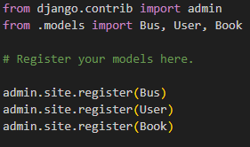

**Apps.py**

**Forms.py**

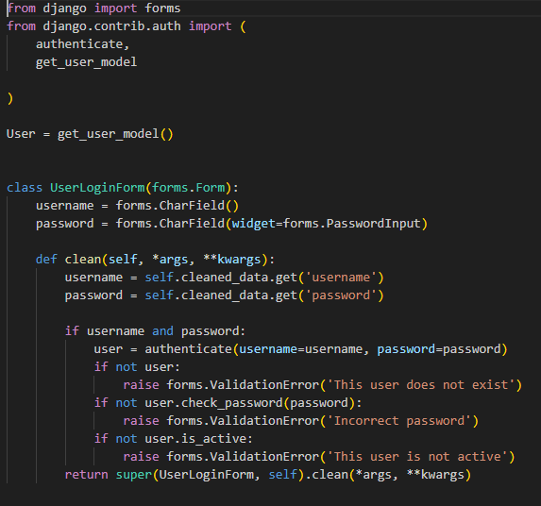

**Models.py**

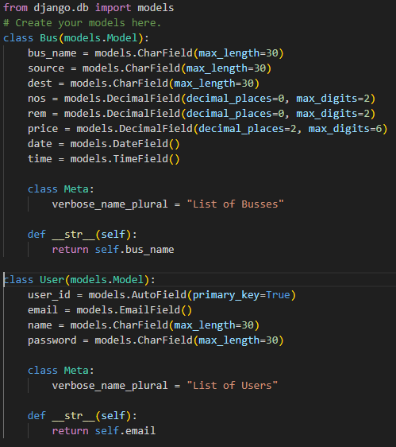

**Tests.py**

**Urls.py**

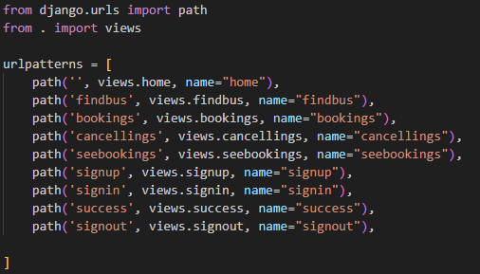

**Views.py**

**B). MY PROJECT**

**Settings.py**

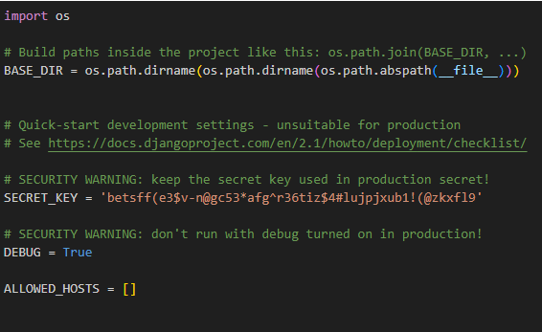

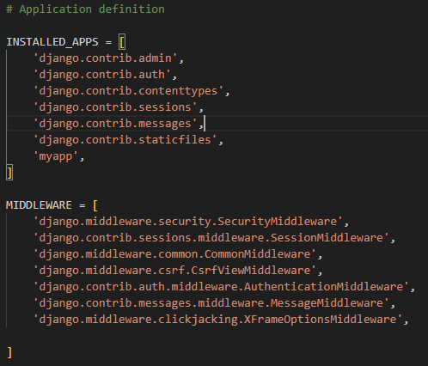

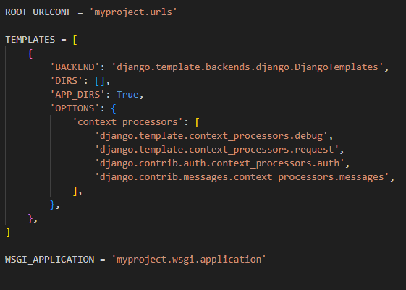

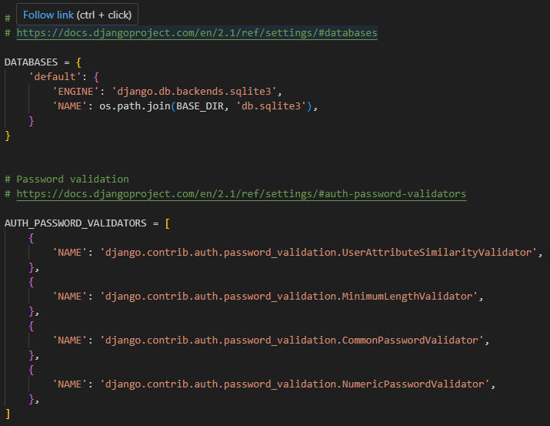

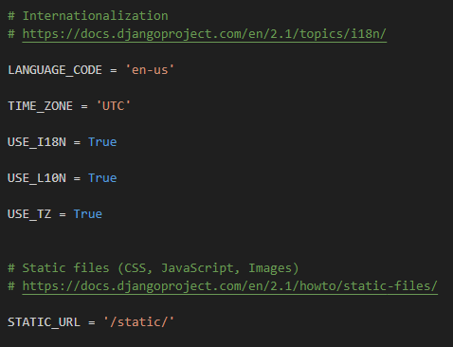

**Urls.py**

**C). MANAGER**

**Manage.py**

**OUTPUT**

**Registration Page**

**Login Page**

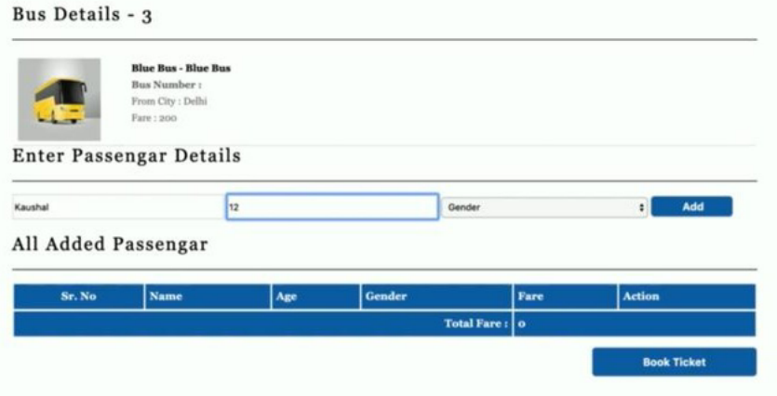

**SUMMARY**

In 1974, American airlines were the first to use an automated booking system, which was still almost manual. Technology grew, and a computer reservation system was developed. In this present era, online booking or reservation system has improved the operations of various sectors of a nation’s economy deploying this system. Online Bus Ticket Reservation System being a web-based system that ensures that the company would be able to transform most of the processes carried out manually into automated, error-free and easy to use operations in the organization especially in the area of transportation; also, it would be able to generate report for the management decision purpose. This system will be developed using a waterfall methodology for research and design purposes, PHP as the programming language because of its server-side processing capabilities that makes data process less on the client personal computer, an implementation strategy as well as testing and maintenance strategies suitable for efficient deployment of the system.

**RECOMMENDATIONS**

Research and development are continuous processes; this is the same in computer and software development. However, this work is recommended for Imo Transport Company Limited, Owerri, since their operation are still carried out manually and it can also be useful to other Bus Transportation industries whose processes are still manually done. The system can contribute more on those bus representatives handling the account if it can generate reports by trip so that they will no longer go to a certain module to check the reservation and its details. Also, it will be more beneficial to both clients and bus representatives if clients can create an account just like in airlines websites. With that, the system can record the modifications made. Other functionalities such as E-Mail facility for sending Ticket to passenger, Online Payment with Credit Card / Debit Card etc. could also be integrated into the system to enhance user friendliness and interactions.

**CONCLUSION**

It can be observed that computer applications are very important in every field of human endeavour. Here all the information about customer that made reservation can be gotten just by clicking a button with this new system, some of the difficulties encountered with the manual system are overcome. It will also reduce the workload of the staff, reduce the time used for making reservation at the bus terminal and increase efficiency. The application also can update records in various files automatically thereby relieving the company’s staff the stress of working from file security of data.

This project will give a new way in bus reservations and ticketing processes. The automation and management of seats and reservations will be done online. However, this project does not limit the walk-in passengers that is passengers who visit the company’s counter because it also caters for them. This also lessens the use of papers like in the traditional way of ticketing.